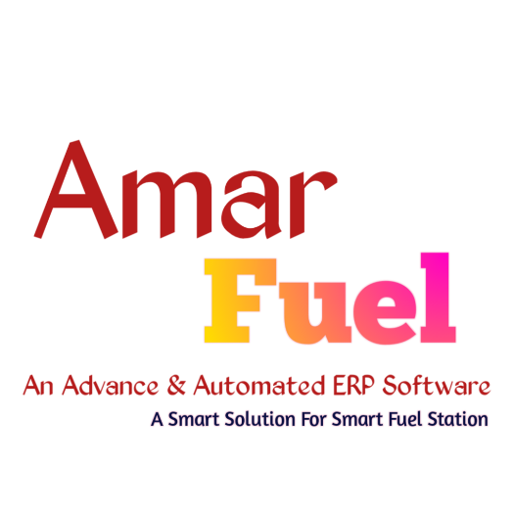

**Amar Fuel** is a powerful modern forecourt controller for provision of control over:

* petroleum, LPG and CNG dispensers
* automatic tank gauge systems and probes
* price signs
* RFID readers

[Cite your source here.]

Details

**Amar Fuel knows communication protocols of a great variety of dispensers, ATG systems and probes, price boards and readers allowing to control over any of them in a common way regardless of the brand or communication protocol used, so using the Amar Fuel controller any management system (POS system, OPT, mobile application) can use a common way for provision of control over any supported brands in the same way. Amar Fuel controller leads internal database for pumps sales and tanks measurements, it allows to generate reports using a web browser and also can automatically upload all the registered records to any cloud server, allowing to easily remotely receive all detailed reports from the petrol stations and petroleum depots.**

|  |  |  |  |
| --- | --- | --- | --- |
| **Products’ Name** | **Technical Specification** | **Product’s Picture** | **Price/ Unit In BDT** |
| AmarFuel Forecourt | **Capacity: Unlimited**  **Offline Record: 6000**  **Live Sell: Yes**  **Nozzle: 32 Nozzle**  **Wi-Fi**  **RFID + QR Code**  **Wi-Fi Range: 300M**  **MODBUS RS485/RS422**  **Server**  **Full Network Support** |  | **140,000 BDT** |
| **Domain** | **sheba.amarfuel.com** |  | 1,500 BDT/ Year |
| **Server** | **10 GB BDIX Server NVMe**  **30 GB BDIX Server Raid 10** |  | 3,500 BDT / Month  6,500 BDT / Month |
| **Software** | Nozzle live Data Read & Maintain,  **Report Generation** |  | (Free With Device) |
| **Total** |  |  | 1,45,000 BDT |
|  |  | **Paid** |  |
|  |  | Payable |  |

|  |  |  |  |
| --- | --- | --- | --- |
| No. Of Nozzle | Service Charge Per Fuel /Gas Station | | Service |
| Monthly | Yearly | (5 free Service After sell for 3 months) |

|  |  |  |  |  |
| --- | --- | --- | --- | --- |
| 1 | 32 Nozzle | 3500 | 40,000 | 1500 |
| 2 | 1-5 | 1500 | 26,000 | 1500 |
| 3 | 32 Nozzle | 6500 | 70000 | 1500 |
| 4 | 15+ | 6500 | 74,000 | 1000 |

**Software Specification**

* Monitor Daily Sales
* Nozzle Monitoring
* Sales Receipts to Customer
* Dashboard to monitor their history
* Daily Report
* Shift Closing Report

**Hardware Specification**

* Support up to 32 Nozzle Dispensers
* Support RFID readers
* Support Fingerprint scanner
* Support Bluetooth / Wi-Fi Printer
* Support Price Board
* Range Wi-Fi Long (200M+)
* Able to work automatically standalone.
* Network Monitoring

**Security Specification**

* Strong authentication mechanisms to ensure that only authorized devices and users can access our API. Consider using technologies **OAuth 2.0** for authentication and role-based access control (RBAC) for authorization.
* Secure communication channels such as **HTTPS** (HTTP over TLS) to prevent data interception and man-in-the-middle attacks.
* **Firmware and Software Updates**: Regularly update the firmware and software of devices to patch vulnerabilities and improve security.
* **API Versioning**: Use versioning in your API to maintain backward compatibility while introducing security enhancements in newer versions.
* Encrypt data transmitted over the API using protocols TLS (Transport Layer Security) to prevent eavesdropping and data tampering during transit.

**Terms & Condition:**

1) Device warranty will be valid for 24 months for any kind of manufacturing fault and Service warranty 5 years from the date of successful installation for above mentioned product.

2) This work order is made on the assumption that as an expert is providing

the most suitable device at a fair price and will ensure 100% data security.

3) The software must include features such as: #log-in system for individual, #Shift Opening

System, #Date range wise Total Sales report with filter in header, Header can be date, Nozzle

number, Octane, Diesel, Shift, Amount, Ltr, Etc, #History of sales.

4) For any minimum modification, Amar Fuel will support us on a payment base.

5) Payment should be done by A/C Payee Cheque or Cash.

6) Monthly maintenance fee of the software for 1 device will be Tk. 3500 will be applicable.

7) Amar Fuel uses fuel dispensers as part of its operations. However, Amar Fuel will not take responsibility for any faults, defects, or issues related to the fuel dispensers. It is the customer's responsibility to ensure the proper use and safety of the fuel dispensers. Amar Fuel will not provide any compensation or damages for any issues arising from the use of the fuel dispensers.

Shah Mohammad Abdullah,

Managing Director,

Sheba Green Filling Station

Shah Newaz Aziz,

Managing Director,

Amar Fuel